* Introduction

Acceissibility, Security, Users

* Sub-system and interface definitions
  + Cloud Storage – UI
    - Data transmition must be done so securely
    - All data must be transmitted in the same format to avoid formatting errors
    - Data must be transferred wirelessly
* Design Specifications

Specify users – age group, accessibility test

* + Accessible from any internet connected device
  + Minimal setup
  + Minimal system requirements
  + Capable of communication with cloud data
  + Private data protected via secure login page
  + Differing levels of access based on password clearance level
  + System status indicator with sync status and last update time stamp
  + All pages use high contrast display colours to improve readability
  + Navigation made simple through icons including undo, redo and home buttons
  + Errors should be prevented or flagged and where this is not possible, the cause and solution should be presented to user clearly
  + All graphics, language and terminology should be intuitive and consistent throughout
  + Minimalist aesthetic to prevent confusion on the part of the user
  + 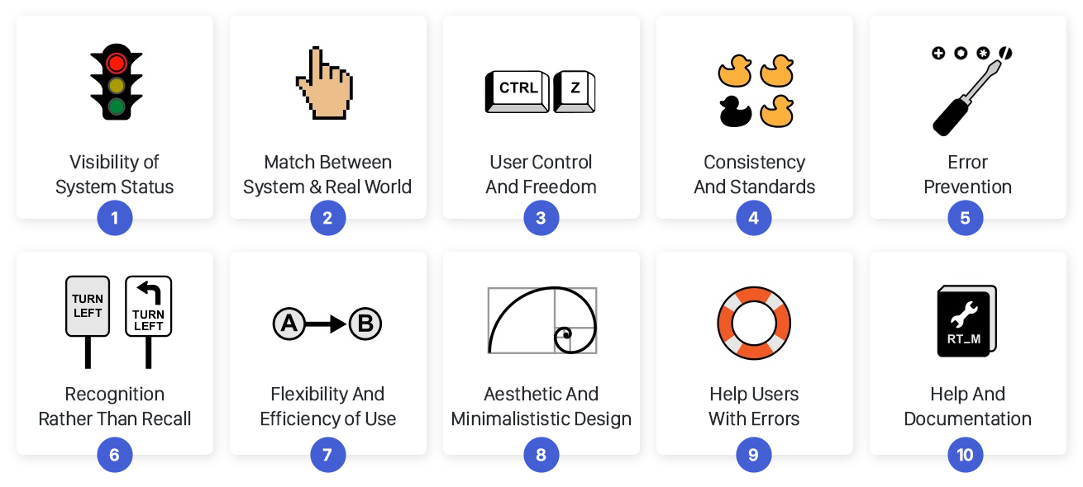
* My Sub-system
  + Alternative Designs – write about pros and cons of each
    - Web Application
    - Desktop Application
    - Mobile Application
  + Web Application probably best due to cross-platform compatibility and lack of installation
  + Assessment of Alternatives
    - Criteria for assessing
      * Setup difficulty
      * Cross-platform compatibility
      * Cyber-security
      * ????
  + Design Validation
    - “[Detail the simulations or measurements used to show that the design of the subsystem works. Detail the simulations or measurements the Group used to show that the complete system works.]”
      * What does it mean by works? Show that it meets design specs?
    - Best way of prototyping? Build web pages and demonstrate use on different operating systems. This is limited to offline prototype though as I don’t have access to a server.
    - How can I demonstrate communication with cloud???
    - Local server mySQL database and PHP/HTML web application
  + Test Specifications
    - “[Detail the particular tests that are to be made in order to show that the sub-system design meets the Design Specification. Detail the particular tests that are to be made in order to show that the whole product meets the Design Specifications. Indicate the acceptable tolerances on the values to be tested.]”
      * Acceptable tolerances for values? No values for UI
    - Testing could be carried out as a survey eg:
      * What device did you open prototype on?
      * How much prep before you could access UI? 1-10
      * Did you find text easy to read? y/n
      * Was navigation intuitive or confusing? y/n
      * Did you encounter any error messages? y/n
      * Etc.
    - More suggestions for testing?
      * Simple questions like “is there a status bar?” seem useless as they are included in design spec and are therefore present.
* Detailed Sub-System Design
  + User Experience Flow Diagram